PMCMD Command

**Step 1**  
execute the pmrep and pmcmd commands

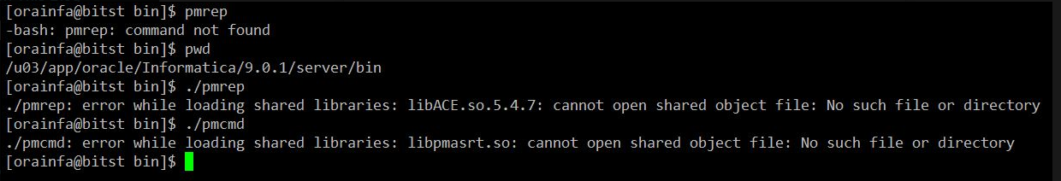

The commands will not be loaded due to the enc variables and the path are not set so we need to set path and the env variables

**Step 2**  
Set the env variables accordingly

export INFA_HOME=/u03/app/oracle/Informatica/9.0.1

export PM_HOME=/u03/app/oracle/Informatica/9.0.1

export PATH=${PATH}:/u03/app/oracle/Informatica/9.0.1/server/bin

export LD_LIBRARY_PATH=${LD_LIBRARY_PATH}:/u03/app/oracle/Informatica/9.0.1/server/bin

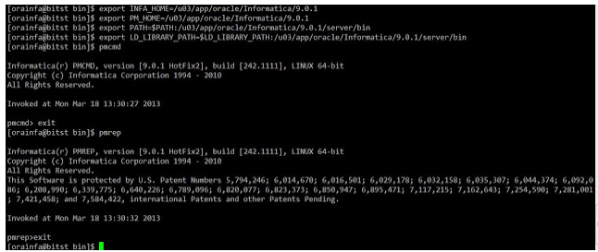

**Step 3**

**pmcmd** startworkflow -sv <**Integration Service Name**> -d <**Domain Name**> -u <**Integration Service Username**> -p <**Password**> -f <**Folder Name>** <**Workflow**>

**pmcmd** startworkflow -sv -d **qpd_Domain** -u **Administrator** -p **admin** -f **Alex wf_sales_tax**

pmcmd startworkflow -sv ESDEV4_NS_IS -d ESPOO8 -u swkadam -p Pakaw@1234 -f PBA_DEV wf_CMD_Customer_Hier_Resolve_Daily